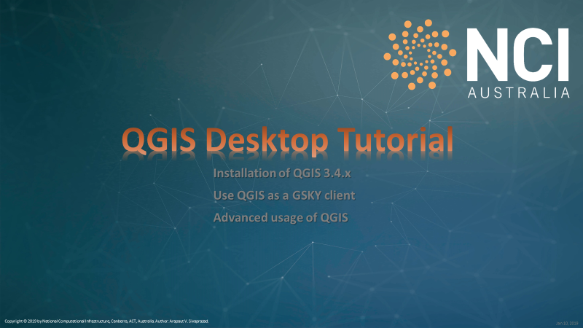

**SUMMARY**

GSKY is currently being delivered through an in-house program, **TerriaMap**[1]. As such, it is fine tuned for displaying the GSKY Map Services. However, there is not a wider user base for TerriaMap and hence to attract more users for the GSKY service we must provide more common GIS software as clients of GSKY server. The QGIS is one of many being considered.

This Word/PDF document is an expanded version of the Power Point presentations that describe the same software and service. The latter are quicker and easier to get a basic understanding, whereas this document gives more in-depth knowledge into the workings.

**DISCLAIMER**

While this document is more detailed, it is by no means a comprehensive documentation for either QGIS or GSKY. You must consult the [QGIS Training Manual](https://docs.qgis.org/testing/en/docs/training_manual/)  and/or the [GSKY Manual](https://gsky-docs-rtd.readthedocs.io/en/latest/index.html) for more details. While every effort has been made to acknowledge the original sources of information, via back links, omissions may exist. This document is based on the author’s current understanding of QGIS and GSKY and may evolve over time.

# INTRODUCTION

The NCI-developed **GSKY** service provides a new approach to online analysis and visualisation of environmental data. GSKY provides an ability for users to interact with datasets and the information they contain using standard community protocols. [[Ref](https://gsky-docs-rtd.readthedocs.io/en/latest/_overview/overview.html) 1]

GSKY accesses and analyses the big geospatial data on NCI’s cloud and high-performance computing systems, and then delivers it to a user device or website. For example, hundreds of time series and geospatially overlapping data can be seamlessly merged together, allowing researchers to focus on the information rather than dealing with data files. Furthermore, using GSKY’s processing capability, that data can be analysed on the fly using user-provided algorithms to extract new information over both space and time. [[Ref](https://gsky-docs-rtd.readthedocs.io/en/latest/_overview/overview.html) 1]

Behind the scenes, GSKY works out how to manipulate the datasets so that they seamlessly work together. For example, in large-scale environmental analyses, the images from different satellites can be in different shapes and sizes, environmental survey data can come in many different formats, and even urban boundary maps need to be considered. As a user of GSKY, working with data is as easy as choosing from a list of available datasets, specifying a region and time frame, and asking GSKY to analyse the information as harmonised data. GSKY then returns the results of the data required, which can be accessed over the network to the client application or for visualisation in an online map. [[Ref](https://gsky-docs-rtd.readthedocs.io/en/latest/_overview/overview.html) 1]

The CSIRO-developed **TerriaMAP** is derived from **TerriaJS** which an open-source framework for web-based geospatial catalogue explorers. TerriaJS is an innovative open source solution enabling publishers to efficiently get their spatial data on the web, including 3D and 4D data. [[Ref](https://terria.io/) 2]

Assemble catalogues of spatial datasets with a combination of hand curation and live querying of online data services. TerriaJS powers world-leading platforms such as Australia's NationalMap and the Australian Renewable Energy Mapping Infrastructure (AREMI), and facilitates the exploration of satellite imagery from Digital Earth Australia. [[Ref](https://terria.io/) 2]

**QGIS** is a user-friendly Open Source Geographic Information System (GIS) licensed under the GNU General Public License. QGIS is an official project of the Open Source Geospatial Foundation (OSGeo). It runs on Linux, Unix, Mac OSX, Windows and Android and supports numerous vector, raster, and database formats and functionalities [[Ref](https://qgis.org/en/site/about/index.html) 3]

# RATIONALE

QGIS is a much more widely used GIS software and as such its user-base would be considerably larger than that of TerriaMap. More organisations may be inclined to use the GSKY service if QGIS can be demonstrated as its client. Besides the ubiquity of QGIS, the various functions and settings available in this software may become useful for analysing the GSKY-provided data in a much more meaningful way. It may also lead to adding more functions into GSKY itself.

# SCOPE OF THIS DOCUMENT

This document is primarily intended to be a beginner’s resource to learn the use of QGIS as a GSKY client software. It is based on the Power Point Presentations of the same material, with added explanations and different methods of navigation. Together with the PPTX this document is expected to give the necessary basic understanding to use QGIS as a GSKY client. While the PPTX is a 10-minute study resource, this document may require 2 – 3 hours to learn fully. It will be more useful as a reference document after you have started using QGIS.

# STRUCTURE OF THE DOCUMENT

The pages that follow will display each slide in the PPTX with descriptive text for the steps in each slide. The graphics and text that are animated in the PPTX are displayed here as static images and text. To prevent cluttering, some sections may be hidden.

## Slide 2

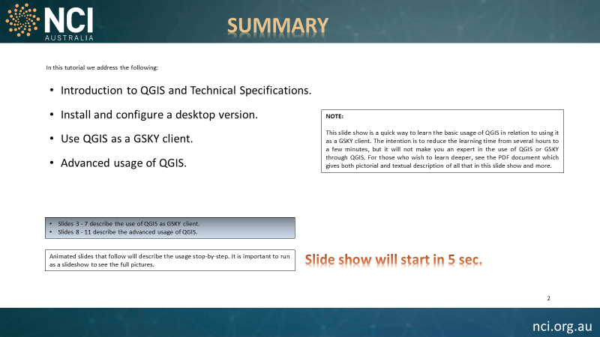

This is a summary slide that says what to expect in the PPTX presentation.

## Slide 3

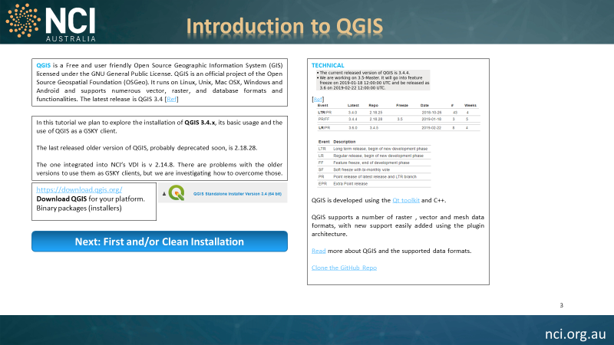

This slide gives a basic description about QGIS and its Release Roadmap. The latest stable version at the time of writing this document was QGIS 3.4.4-3. However, the public [download link](http://qgis.org/downloads/QGIS-OSGeo4W-3.4.4-1-Setup-x86_64.exe) led to v 3.4.4‑1 instead of [3.4.4-3](http://download.osgeo.org/qgis/win64/QGIS-OSGeo4W-3.4.4-3-Setup-x86_64.exe) that is available in the background. Both appeared to be identical in all the tested areas and are not expected to differ in the next release. The release [roadmap](https://qgis.org/en/site/getinvolved/development/roadmap.html#location-of-prereleases-nightly-builds) states that 3.4.4 will be released as v 3.6.0 on 22 Feb, 2019 but may not replace 3.4.0 until an unspecified time in the future.

QGIS is developed using the [Qt toolkit](https://qt.io/) and C++.

[Read](https://github.com/qgis/QGIS/blob/master/README.md) more about QGIS and the supported data formats.

[Clone the GitHub Repo](https://github.com/qgis/QGIS)

[<https://download.qgis.org/>](https://download.qgis.org/)

**Download QGIS** for your platform. Binary packages (installers)

## Slide 4

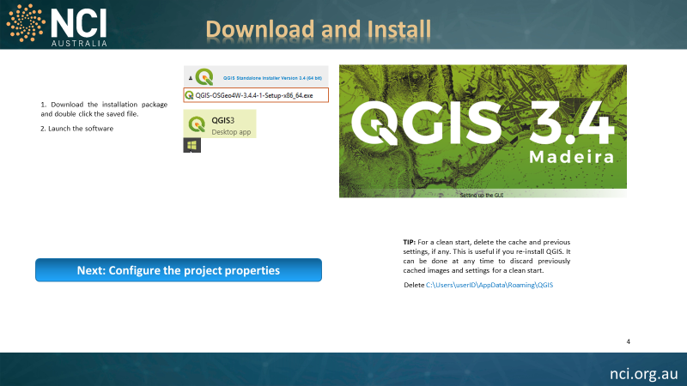

This is an animated slide that shows the process of downloading and installing QGIS 3.4.4.x. Just by looking at the slide it is not possible to see all controls and processes. It must be run as a slide show to see the process in action.

To run slide-show:

* Top menu bar: Click ‘Slide Show | From Current Slide’
* Bottom status bar: The slide-show icon ()
  + Will run the show automatically.
  + Turn off the ‘Use Timings’ for manual control.
  + Left arrow to stop and rewind to beginning.
  + Right-arrow to forward manually.
  + Esc to cancel the slide show.

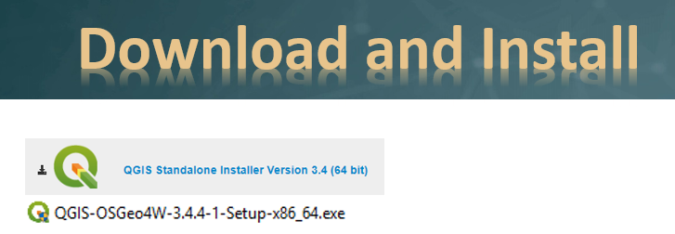

* Double-click the saved file to start the installation. Requires administrator privilege.

If you have previously installed the software, it will ask whether to uninstall it first. Say OK to uninstall.

If you do not wish to retain previous settings and caches of images and data, you can force a clean installation. Instructions are given later in this slide.

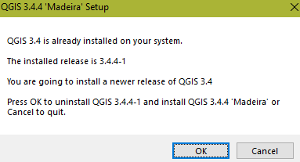

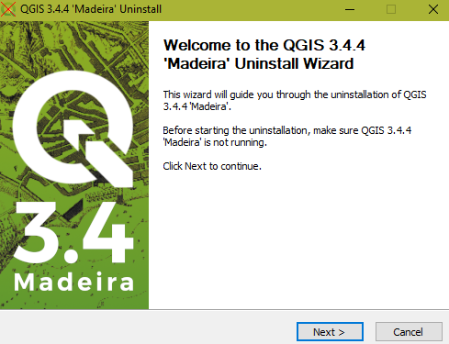

After the Uninstall, if required, it will confirm to install the software. Go through the normal process of installing any Windows software, accepting all defaults.

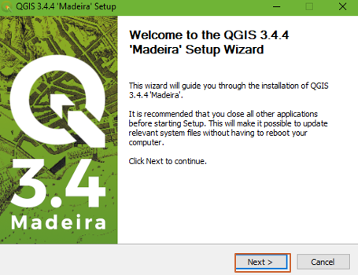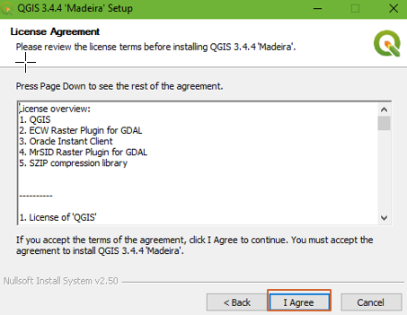

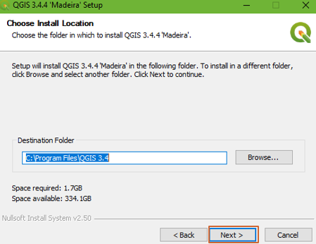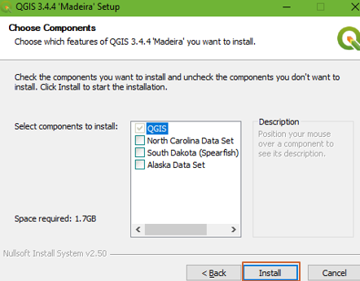

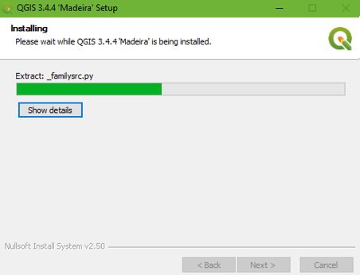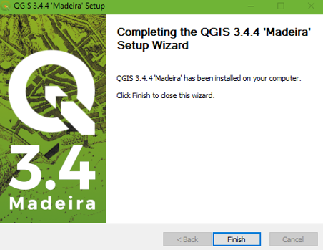

After the program is installed, it can be launched from the Start menu. Though it adds to the start menu, a desktop icon is not created as is normal with others. To launch, click Start and locate the program or type in QGIS to bring it up to the top and click.

This dialog will appear if the QGIS.ini file cannot be found.

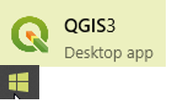 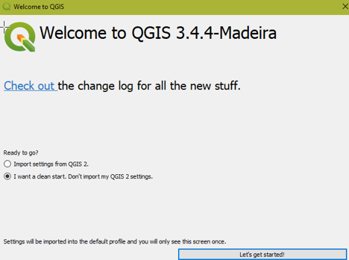

Start the program from the Start menu.

If this is a first-time installation, the start window will ask to confirm a clean installation. If not, it will use the previously set configurations and cached data. If you want to discard all previous settings and data, and force a clean start, then delete or rename the following directory on your PC before launching the software.

   
where ‘avs29’ is your user ID.

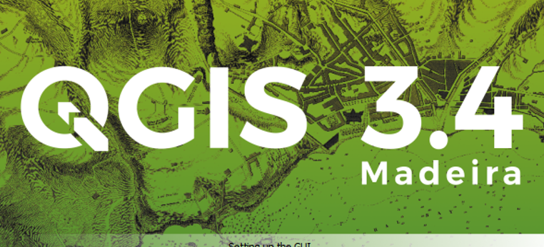 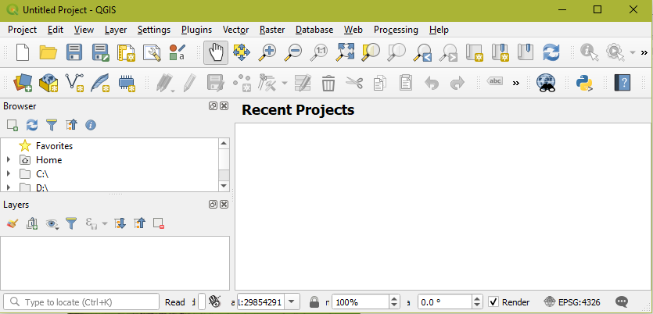

The main window.

Configuring project properties and adding layers will be demonstrated in the next slide onwards.

## Slide 5

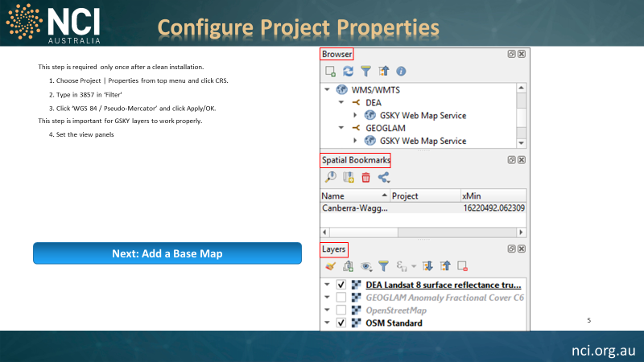

By default, the Coordinate Reference System (CRS or SRS) in QGIS is set as EPSG:4326. It sends the Lat/Lon coordinates as degrees, whereas GSKY expects them in meters. Hence, it is necessary to change this into EPSG:3857

The default CRS is EPSG:4326. GSKY needs EPSG:3857

The main menu. Set the properties first.

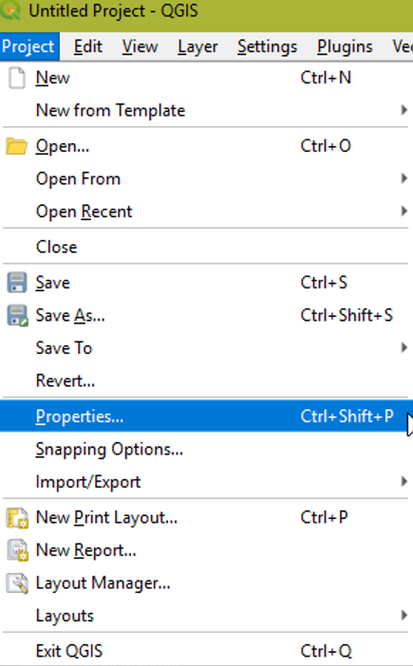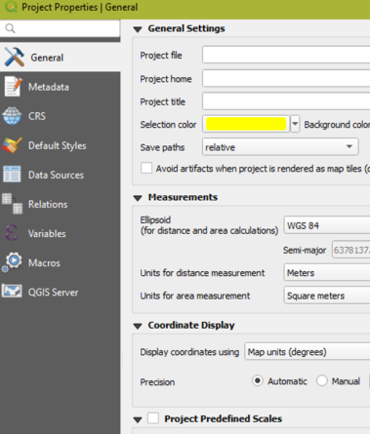

Change the CRS to EPSG:3857

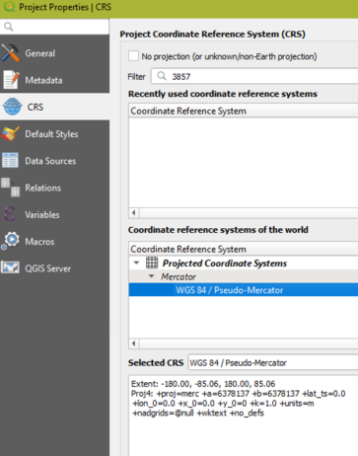

**To set EPSG:3857**

* Click ‘Properties |CRS’
* Type in ‘Filter:3857’
* Click ‘WGS 84 / Pseudo-Mercator’
* Click ‘Apply’ and ‘OK’



The quick access panels on the left border are useful to add/view/mask the layers and views. At a minimum, have three panels – Browser, Layer and Bookmarks – turned on as below.

Panels on the left.

The main menu

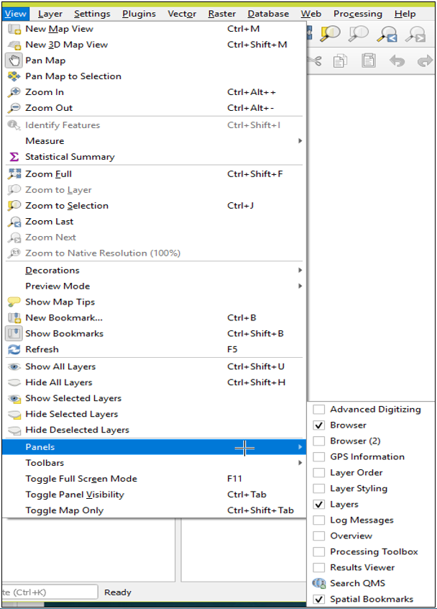 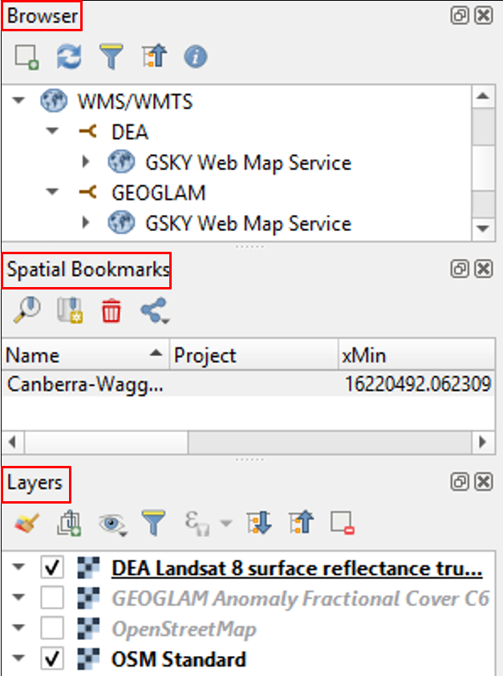

The panels above are showing the layers and bookmarks that are not yet added. Next slide will show how they are added. Before that, we need to add a base map so that the added layers will make sense.

## Slide 6

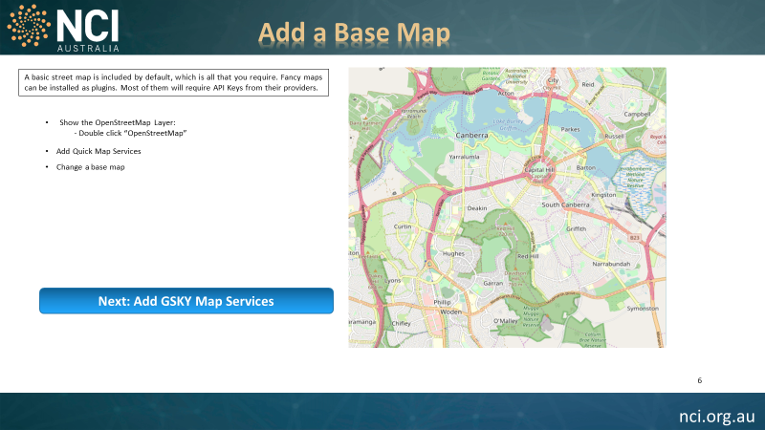

By default, an OpenStreetMap is included in QGIS. You can add it as a base map and do not need another. However, there are plugins to add others.

* Double click ‘XZY Tiles | OpenStreetMap’

Double click “OpenStreetMap” in browser panel

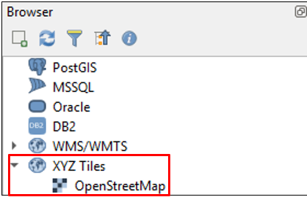

Zoom in to your required view

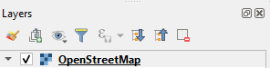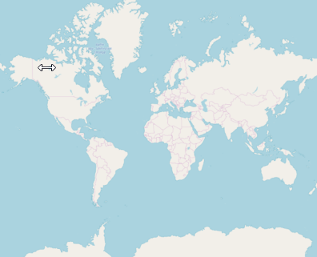 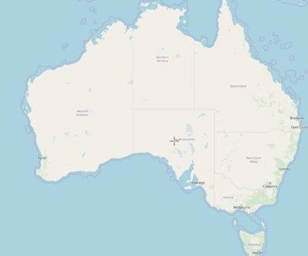 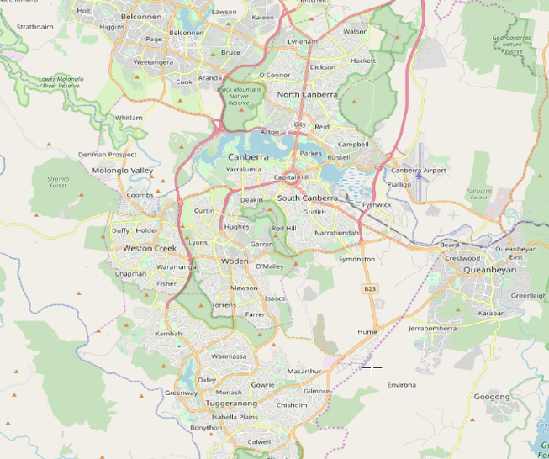

OpenStreetMap layer is added

In addition to the default street map, more can be added as plugins. Most of these will look just as basic as OpenStreetMap unless an API key is obtained from the third-party providers.

Add “QucikMapServices” for more base maps.

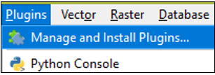 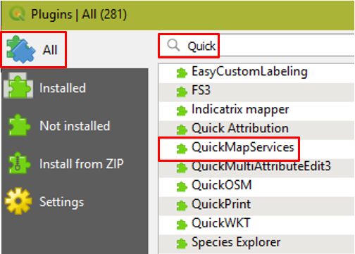 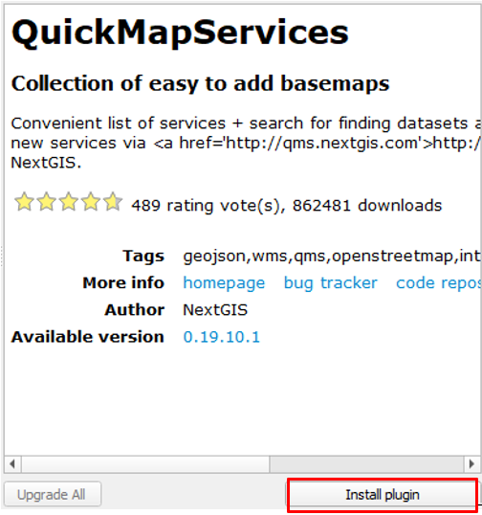

Add a new base map

The main menu to add a plugin

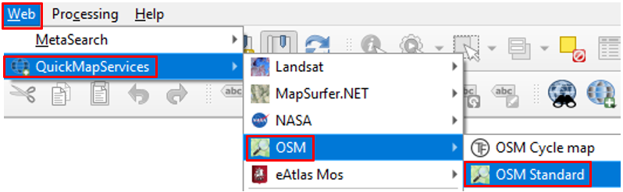

There are several maps and data layers in this plugin. The OSM Standard is the closest to Open Street Map. With the right API keys the others may show more aesthetic maps.

## Slide 7

Now that we have all the necessary settings and base map, we can add the WMS/WMTS layers that will support the GSKY Map Services.

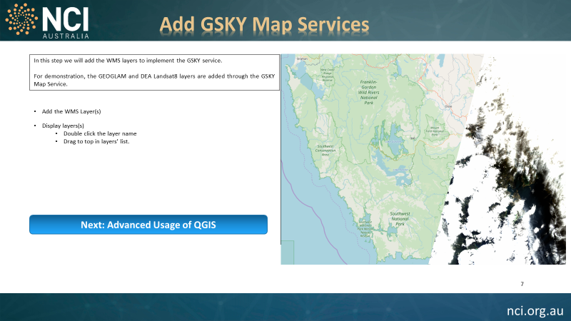

1. Add a WMS Layer: Layer | Add Layer | Add WMS/WMTS Layer

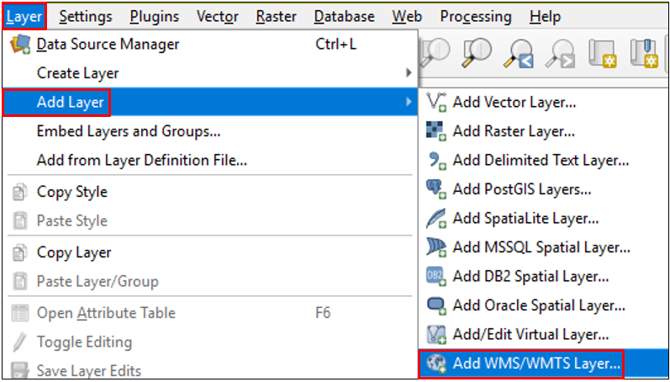 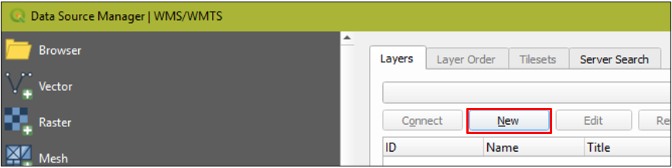

2. Click ‘New’ to add a new layer.

Add a name and the GSKY server URL and press OK. You can add multiple URLS in this way. They will be permanently recorded in the INI file to be used in QGIS subsequent sessions.

4. Click ‘Connect’ to see if the layer is found. This step is not essential.

3. Give a descriptive name and the URL of the layer. Click OK.

Connecting the GSKY service will list all layers in the dataset. This step is not necessary, as it is automatically done by QGIS in the background. You can simply close this dialog without connecting first.

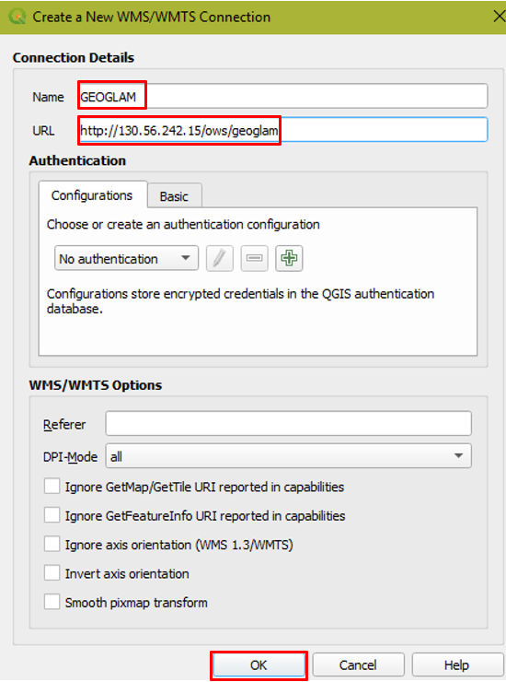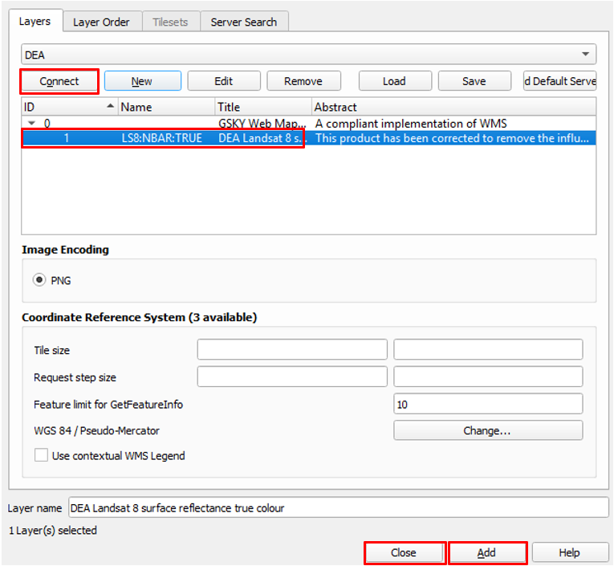

8. Zoom in until the layer shows up.

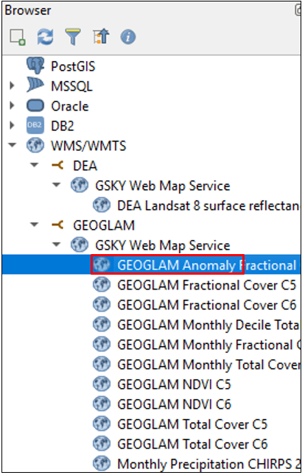

7. Uncheck the current layer and drag another to the top.

6. Check the layers to be shown. Top ones will mask those below.

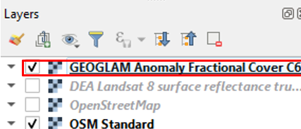

5. Added layers will appear in the Browser panel

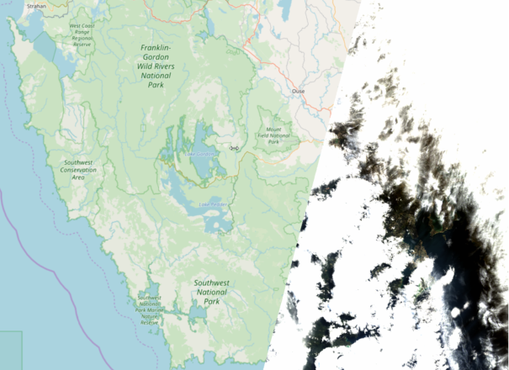

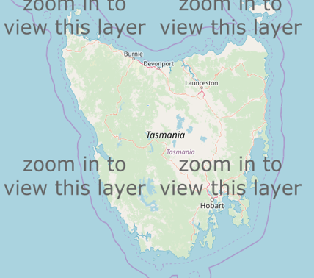

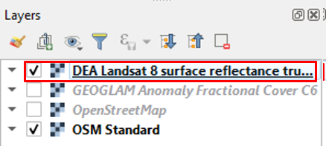

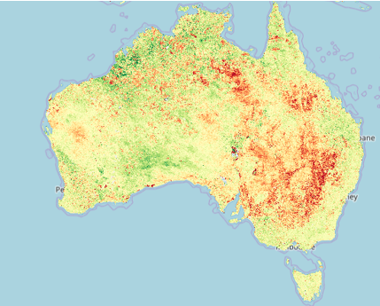

## Slide 8

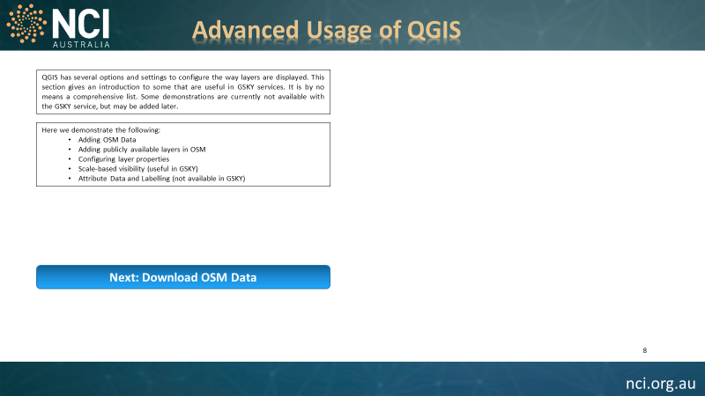

Though it is not in the scope of this document to explore all the advanced features of QGIS, a basic understanding of using layers and its settings will help to visualise the GSKY layers more efficiently. To demonstrate this, we will use a publicly available dataset as a layer.

Here we demonstrate the following:

* + Adding OSM Data
  + Adding publicly available layers in OSM
  + Configuring layer properties
  + Scale-based visibility (useful in GSKY)
  + Attribute Data and Labelling (not available in GSKY)

## Slide 9

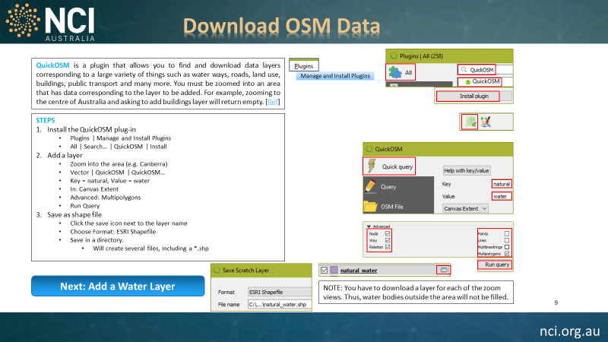

**QuickOSM** is a plugin that allows you to find and download data layers corresponding to a large variety of things such as water ways, roads, land use, buildings, public transport and many more. You must be zoomed into an area that has data corresponding to the layer to be added. For example, zooming to the centre of Australia and asking to add buildings layer will return empty. [[Ref](https://docs.qgis.org/testing/en/docs/training_manual/foreword/preparing_data.html) 4]

The QGIS OpenStreetMap Plugin (QuickOSM) is a plugin for the desktop GIS application [QGIS](https://wiki.openstreetmap.org/wiki/QGIS). It adds support for OpenStreetMap raw vector data, bringing it in as a layer either from .osm [XML](https://wiki.openstreetmap.org/wiki/XML) file or by direct download from the OpenStreetMap [API](https://wiki.openstreetmap.org/wiki/API). It also permits editing and upload back the OSM server. The plugin is at its early stages of development. As of QGIS it has been superseded by functionality in the QGIS core [[Ref](https://wiki.openstreetmap.org/wiki/QGIS_OSM_Plugin) 5].

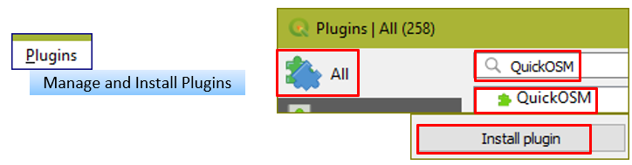 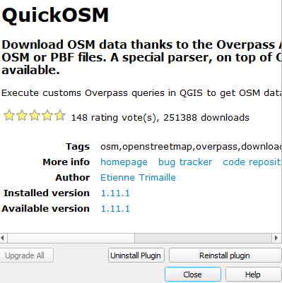

Main menu to add a plugin. Search for QuickOSM and install it.

Upon installing the plugin, a new tool bar will appear showing the following icons. The first icon is the one to access the datasets in this plugin.

We will add a water layer that shows all waterways, lakes and reservoirs in the world.

QuickOSM Toolbar

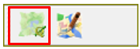

QuickOSM window

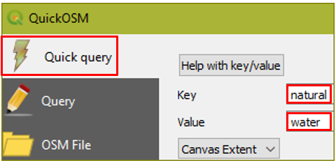

* Click ‘Quick Query’
* Type in key as ‘natural’
* Type in value as ‘water’
* Click ‘Advanced’ and check the items shown.
* Click ‘Run Query’

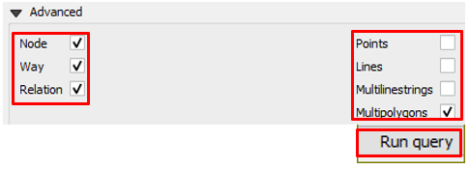

Layer name in the layer panel. Icon is to save it as scratch layer.

Dropdown box for advanced settings. Make sure that only the ones shown below are checked.

* The layer will be added in ‘Layers’ panel.
* Click the icon against it.
* A layer like this is added only to the visible view. If you zoom or pan out, then add again as described above.
* Save the added layer as a scratch layer so that it can later be added as a vector dataset.
* Save as GeoPackage (better) or ESRI Shape File

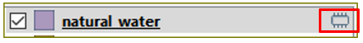

Save the scratch layer as GeoPackage or ESRI Shapefile.

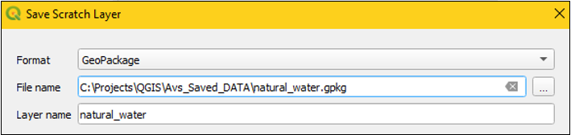

The next slide will show how to add the saved scratch layers as vector datasets.

## Slide 10

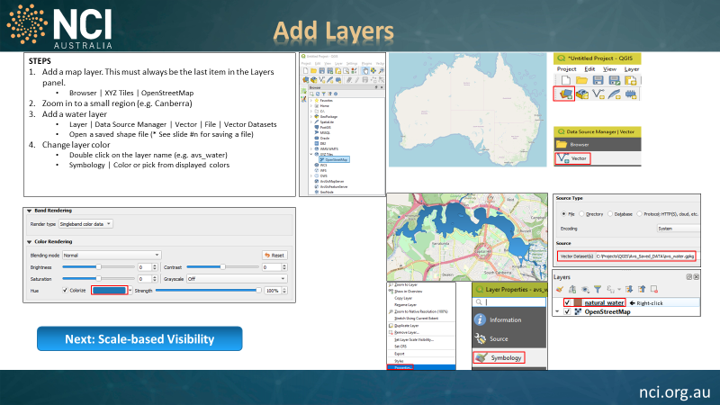

In this slide we will demonstrate the addition of vector dataset layers. Though currently there is no use of this feature for the GSKY data, in future we may support it.

Display the OpenStreetMap and zoom in.

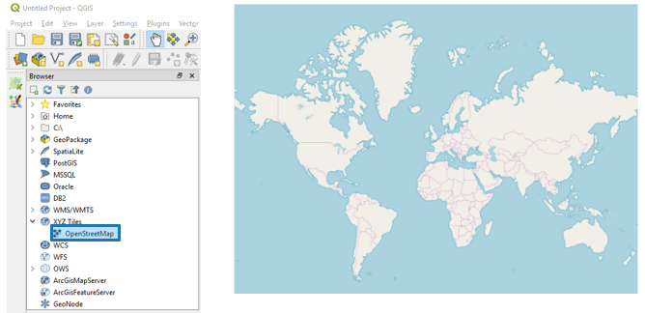

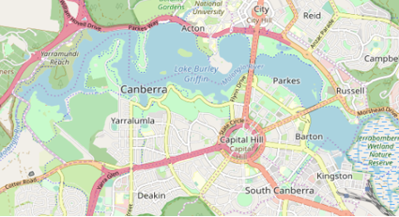

To add a vector layer to the map and change properties:

4. The water layer is now added to the map on right.

5. The water layer shows up as green.

1. Click ‘Open Data Source Manager (^L)”

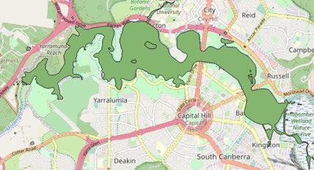

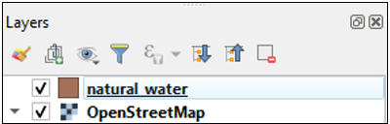

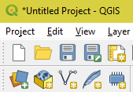

2a. Find the saved *.gpkg file (see previous slide)

3. Click ‘Add” the vector dataset.

2. Click ‘Vector” and find the saved vector file.



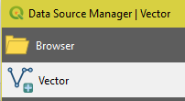

6. Change the properties of the added vector layer. Right click the layer.



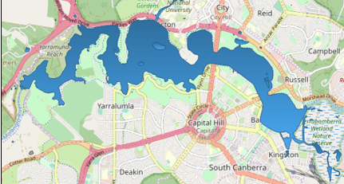

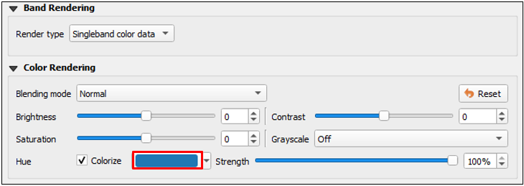

7. Choose Properties…

8. Click Symbology

9. Click “Colorize” and choose a color

10. Water layer changes color.

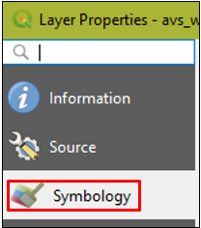

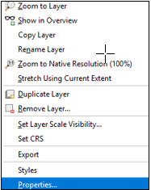

## Slide 11

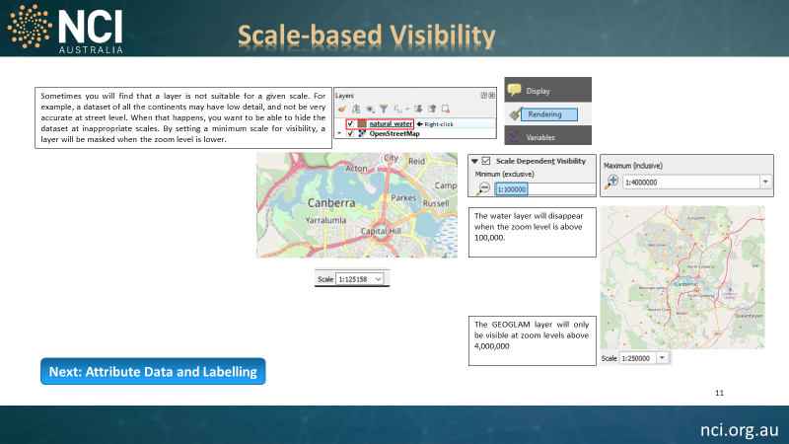

In this slide we demonstrate the scale-based visibility of the added layers. This is a very useful feature to hide/display items that may clutter the display at lower zoom levels or may take extremely long times to display. For example, street names can become cluttered at lower zoom levels. We can specify such that a layer will only be displayed above or below a certain zoom level, or within a specific range.

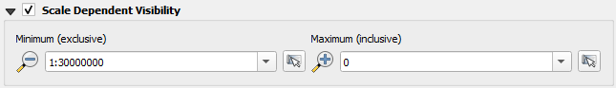

Layer will show when Scale is 1:29,999,999 or lower.

Examples:





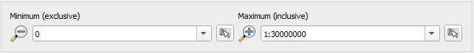

Layer will show when Scale is 1:30,000,000 or higher.

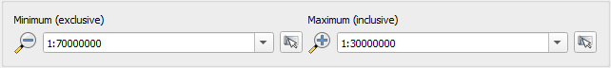

Layer will show when Scale is between 1:30,000,000 and 1:69,999,999.



3. Right click to select Properties…|Rendering

2. The water layer is added to the map.

1. Check the water layer in layer panel

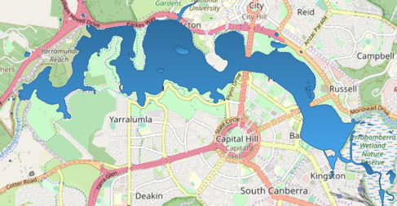  
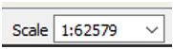

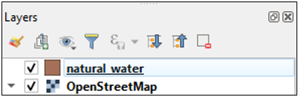

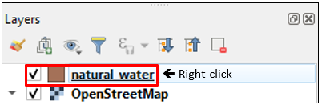

By specifying the minimum and maximum scale values we can control the display of the layers.

4. Give a minimum value. Click apply and OK

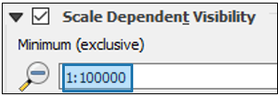

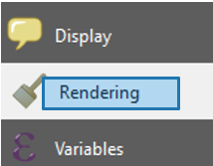

8. Zoom in and the Layer disappears below 4,000,000

7. Layer shows up at above 1:4,000,000

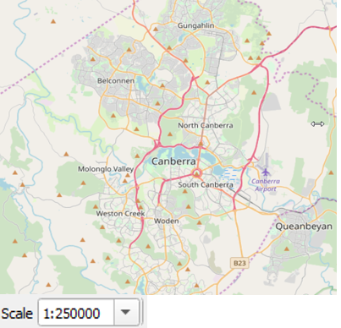

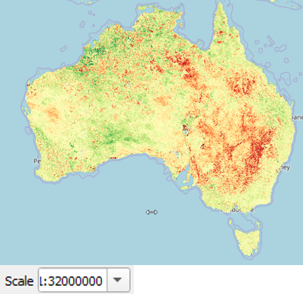

5. Zoom out and see the layer disappearing.

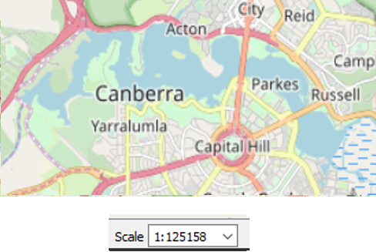

6. Give a maximum value. Click apply and OK

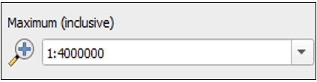

## Slide 12

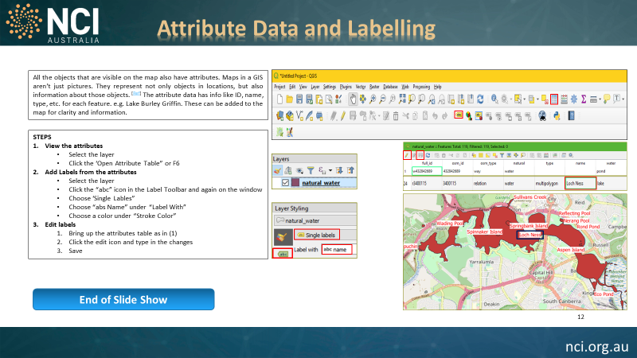

In this slide we demonstrate the use of labelling on the layers. This requires an attribute table associated with the layer. Currently the GSKY layers do not provide it.

2. Click the ‘abc’ icons, above and below, and enter the details as shown below.

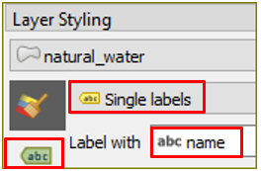

1. If the displayed layer has attribute data, the top tool bar will show the highlighted icons.

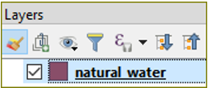

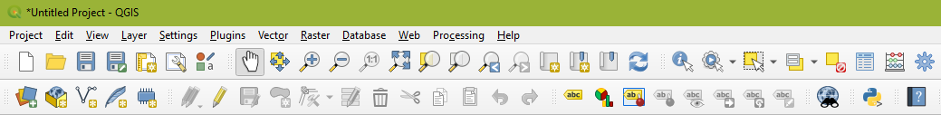

If the layer has an attribute table, you can display/edit it  
with F6 or the table icon on top toolbar.

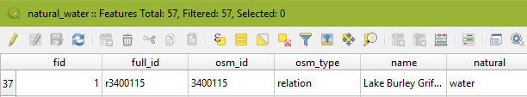

The above will add labels to layer.

4. Click F6 or the table icon in the top tool bar to bring up the data table.

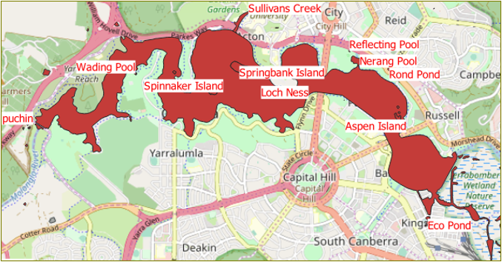

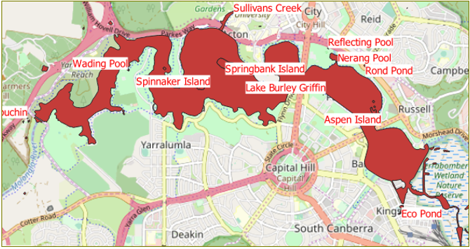

6. The changed label appears on the map.

3. Labels are added to the map.

Edit the name in the attribute table.

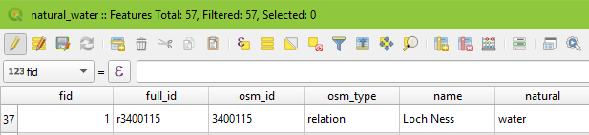

5. Click the edit icon and change the text under the name column. Click the save icon.

1. TerriaMap is a derivative of the public domain program, TerriaJS, developed by CSIRO for use as a GSKY client software for two specific organisations, viz. GEOGLAM and GeoScience Australia.